Week 4 – In Class Lab

Luca Novello | 038515003 | gnovello

## Short Explanation:

I created different Classes for each payment type to handle their unique attributes. The customer can place an Order, the Order can process 1 or many Payments. A Payment has a Customer, and a Customer can have 0 or many PaymentTypes of 1 of the 3 PaymentTypes available. I used an enumeration class to show the limited options. I think maybe using base and sub classes would work better but I am probably just overthinking it again.

Controller Classes:  
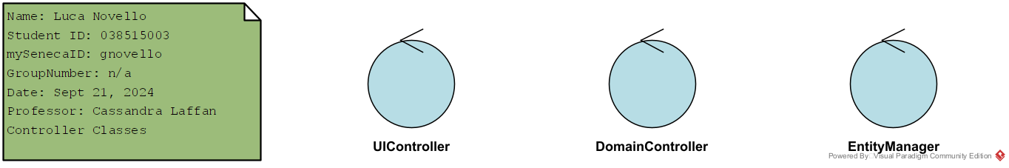

PaymentType Classes:

